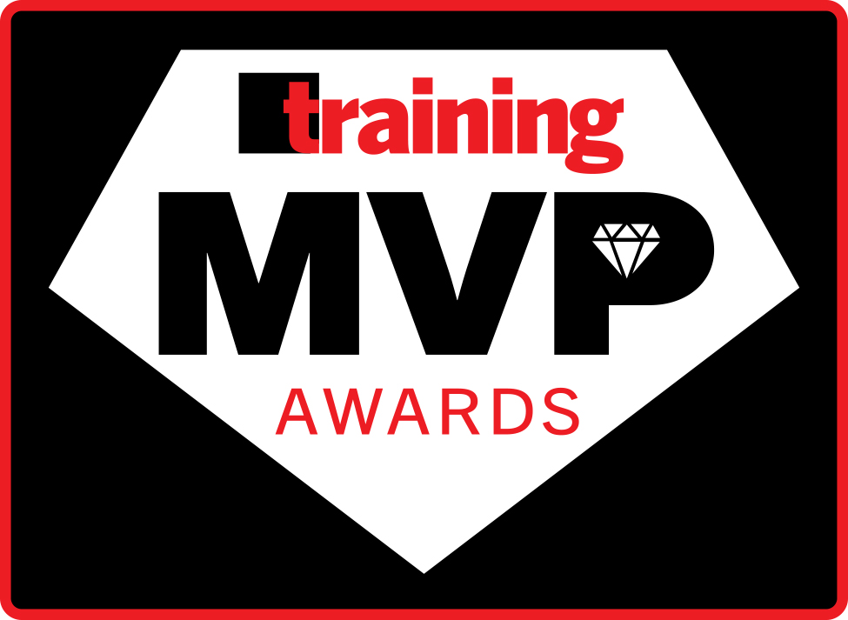

2027 TRAINING MVP AWARDS QUANTITATIVE SCORING GUIDELINES

The following is a detailed breakdown of the quantitative scoring model for the 2027 Training MVP Awards Program.

For the quantitative portion of the score, an applicant can score a maximum of 75 points.

The Application is divided into 5 different evaluation sections:

- TRAINING PROGRAM/SCOPE SECTION SCORE 23 pts.
- TUITION SECTION SCORE 8 pts.
- TRAINING TECHNOLOGY SYSTEMS/DELIVERY SECTION SCORE
8 pts.
- EVALUATION / METRIC SECTION SCORE 16 pts.
- HR SECTION SCORE 20 pts.

The maximum qualitative score is 53, with up to one bonus point awarded for the position on the previous year’s list and a second bonus point awarded for completing the application in house without hiring an outside consultant for assistance. That adds up to a total score of 130 (75+53+1+1). Please see the qualitative scoring guidelines document for the qualitative scoring criteria.

The following pages detail how each section of the application is scored quantitatively by an outside research company.
Below, each section is detailed as to what questions will be scored and the values assigned to applicable responses.

TRAINING PROGRAM/SCOPE SECTION SCORE

Questions:
2.20 + 2.21 | Formal Programs (20 total programs listed) (10 points) | - .10 is scored for each program when selected as “seldom”  - .25 is scored for each program when selected as “often”  - .5 is scored for each program when selected as “always”  No score is awarded to any program for any other response; highest score for this section is 10
2.22 | Informal Learning (8 types) (2 points) | .25 for each Yes answer
2.3 | Hours (2 points) | A calculation is performed to generate an “average” of hours of training for all employee categories (the sum of all the hours in section 2.3 divided by the 9 categories)  Based on the “average” hours trained, a score is assigned as:  - 1 point 20-40 hours  - 2 points more than 40 hours
2.4 | Ratio of Trainers to Employees  (2 points) | Total trainer number {Q2.4} (Full-Time and Part-Time summed)  Number of employees {2.14a+b}  Based on the “ratio” result, a score is assigned as:  - .5 point for 301-400 employees per trainer  - 1 for 251-300 employees per trainer  - 1.5 for 201-250 employees per trainer  - 2 for 200 or fewer employees per trainer
2.6 | Percent of Payroll (3 points) | Points are awarded for a percentage of payroll as provided:  - 0 for less than 1%  - 1 point for 1% to 3%  - 2 for 3.1% to 7%  - 3 for more than 7%
2.61 | Cost Savings  (2 points) | Scoring is as follows:  - 0 for less than 0.0001%  - .5 point for 0.0001 to 0.49%  - 1 for .5 to 1%  - 1.5 for 1.1 to 3%  - 2 for greater than 3%
2.63 | L&D Decisions (2 points) | Scoring is as follows:  - .40 point for each Always answer  - .20 point for each Often answer
TOTAL POSSIBLE SCORE |  | 23 POINTS

TUITION SECTION SCORE

Questions
2.8 | Tuition Participation (.5 point) | Points are awarded for tuition participation as provided:  - .15 for less than 5%  - .25 for 5-10%  - .5 for more than 10%
2.9 | Maximum Tuition (.5 point) | Points are awarded for a company’s tuition reimbursement maximum.  - 0 for less than $1,000  - .10 for $1,000-$2,000  - .15 for $2,001 to $5,250  - .25 for more than $5,250  - .5 for no maximum
2.10a | Tuition Conditions (3 points) | Companies that respond as always for the questions of tuition prepaid (e), and materials included (f) receive .75 point for each; often answers receive .25 point each  For questions a-d, g, h, companies receive .25 point for never answers and .15 for seldom answers
2.10b | Other Payments (4 points) | - Pays 100% for all: .75 for a-e  .25 for f  - Pays a portion for all: .25  - Pays 100% for some: .25  - Pays a portion for some: .15  - Does not pay for at all: 0 points
TOTAL POSSIBLE SCORE |  | 8 POINTS

TRAINING TECHNOLOGY SYSTEMS AND DELIVERY SECTION SCORE

Questions
2.12 | Types of technology systems used to support delivery and management of training and development (1 point) | .25 for each Yes answer:  Learning Management System  Talent Management Systems  Workforce Management System  Employee Performance Support System
2.13 | Delivery methods (7 points) | .25 point is awarded to each valid method (14 possible) that is selected as a delivery method with an example; AND .25 is awarded for each learner engagement element provided (14 possible)
TOTAL POSSIBLE SCORE |  | 8 POINTS

EVALUATION / METRIC SECTION SCORE

Questions
3.1 | Evaluation (9 points) | 1 point is awarded to a company for each of the following (4 points total):  - Return on Value  - Return on Investment  - Balanced Scorecard  - Six Sigma  .5 point is awarded each for Kirkpatrick Level 1 and 2; 1.25 point for Level 3 and 1.75 for Level 4 (4 points total)  1 point is awarded for an additional evaluation program provided as a valid “other” (must be different from the other categories listed)
3.2 | Metrics (7points) | .5 point is awarded to a company for each Business Metric used, including a valid “other” (must be different from the other categories listed)
TOTAL POSSIBLE SCORE |  | 16 POINTS

HR SECTION SCORE

Questions
3.3 | Competency maps (3 points) | 3 points are awarded if the company indicates it uses competency maps
3.4 | Manager compensation tied to development of direct reports  (2 points) | 2 points are awarded if the company ties manager compensation to development of direct reports
3.5 | Employee satisfaction or climate surveys (3 points) | 3 points are awarded if the company uses a climate survey or employee satisfaction survey
3.6 | Average length of service  (2 points) | 2 points are awarded if the average length of service for employees is more than 7 years  1 point is awarded if the average length of service for employees is between 3 and 7 years
3.8 | Turnover (3 points) | 3 points are awarded if the reported turnover rate is less than 10%  2 points are awarded if the reported turnover rate is less than 25%  1 point is awarded if the reported turnover rate is less than 50%
3.9 | Job openings filled by internal candidates (3 points) | A company is awarded point values based on the % that job openings were filled by internal candidates as follows:  - .5 point if 1-25%  - 1 point if 26-50%  - 2 points if 51-75%  - 3 points if more than 75%
3.10 | Percentage of new hires referred by employees  (2 points) | A company is awarded point values based on the % that new hires were referred:  - .5 point if 1-25%  - 1 point if 26-50%  - 1.5 points if 51-75%  - 2 points if more than 75%
3.11 | Company growth (2 points) | A company is awarded point values based on the % of new hires vs. overall employees:  - .5 point if 1-10%  - 1 point if 11-20%  - 1.5 points if 21-30%  - 2 points if more than 30%
TOTAL POSSIBLE SCORE |  | 20 POINTS

BONUS SCORE FOR PREVIOUS YEAR’S RANKING:
.25 point for ranking 76 and above
.50 point for ranking 75 to 26
1 point for ranking 25 to 1

1 BONUS POINT for answering NO to Q3.13:
Did you hire a consultant outside of your organization to assist in completing this application in any way (this includes project management; interviewing business unit leaders; compiling data/metrics; writing, editing, and/or providing suggestions for or feedback on application content; and proofreading)?
NOTE: Applicant must check the acknowledgement box below Q3.13 in order to be eligible for the bonus point if applicable.

